Given a matrix of M x N elements (M rows, N columns), return all elements of the matrix in diagonal order as shown in the below image.

**Example:**

**Input:**

[

[ 1, 2, 3 ],

[ 4, 5, 6 ],

[ 7, 8, 9 ]

]

**Output:** [1,2,4,7,5,3,6,8,9]

**Explanation:**

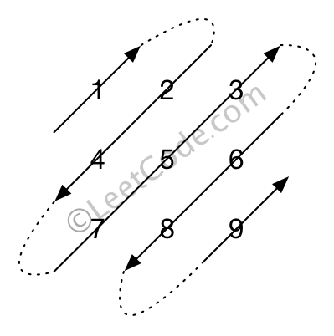

**Note:**

The total number of elements of the given matrix will not exceed 10,000.